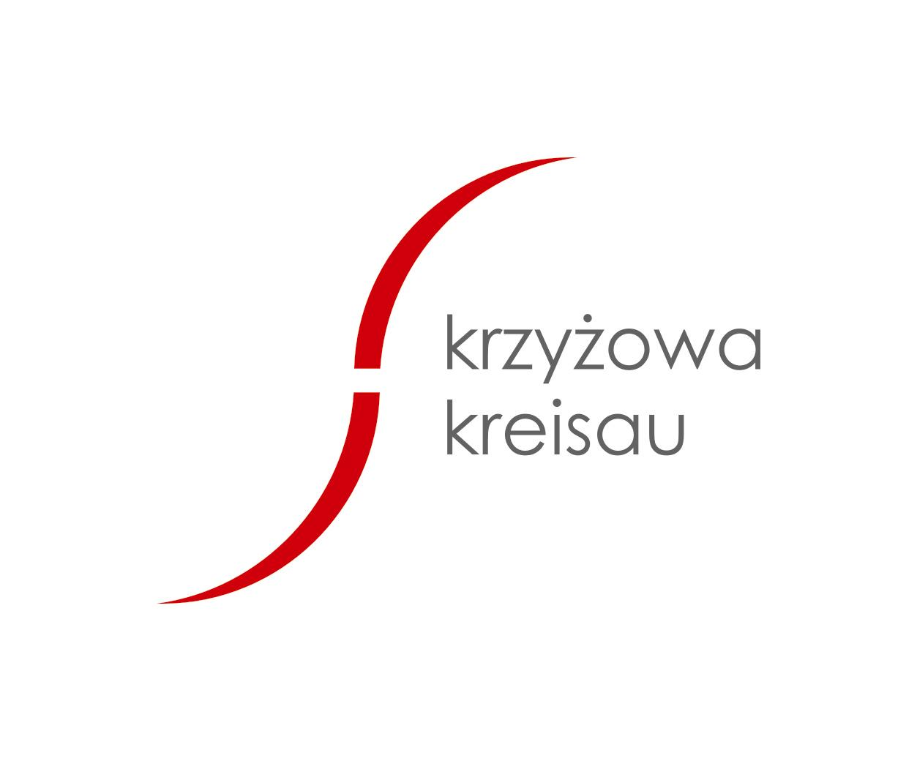
Application
Alternative Triangle of Weimar

Graffiti and Breakdance-Workshop in Krzyżowa

19/08 - 31/08/2007

surname, NAME: | Date of Birth:

ADDRESS:
TELEPHONE: | E-MAIL:
Further Information:

Wegetarian: Yes No

Medical details:

Why would you like to take part in this project?

Did you have any experience with Graffiti in the past?

Which languages do you speak?

Date, place: |  | Signature:

Conditions für Participation:
Number of participants is limited!
The following prices apply to participants from Germany and France.

Graffiti: 250 Euro (program, lodging, full board, material)
70% of the travel expenses will be reimbursed (max. 140€ for german and max. 210€ for french paricipants).

We request an advance of 80 Euro on the following account:

Fundacja „Krzyżowa” dla Porozumienia Europejskiego

Kredyt Bank S.A. I O/ Wrocław
Kt.: (IBAN) PL 49 1500 1155 1211 5003 8197 0000
SWIFT Code KRDBPLPWWRA
With the note: „Graffiti 2007” + NAME OF THE PARTICIPANT

Please send the application form and a copy of the deposit slip until 20th of July 2007 to the address stated below (also possible by fax and e-mail).

The „Krzyżowa“ foundation doesn’t provide insurance coverage. Participants have to organise health-, accident- and liability insurance themselves.

Participants will pay the remaining amount on the day of arrival. In case of cancellation the advance of 80 Euro will not be repayed (unless somebody else is sent as a replacement person).

Underage participants have to send a signed permission of their legal guardians to the address stated below.

Further Information & Application

The Krzyżowa Foundation for Mutual Understanding in Europe Krzyżowa 7, 58-112 Grodziszcze,
Tel.: +4874 8500124 300, Fax: +48 74 8500305
E-Mail: lato@krzyzowa.org.pl

